**Power BI Dashboard**

**Company Revenue & Profitability Analysis**

**Objective:**

To analyze the revenue, expense, and profit performance of the company over the year 2024 across departments and categories, and to identify key drivers of profitability using an interactive Power BI dashboard.

**Step 1: Dataset**

* Department-wise revenue & expense
* Category-wise revenue & profit
* Monthly revenue & expense
* Profit by department & category

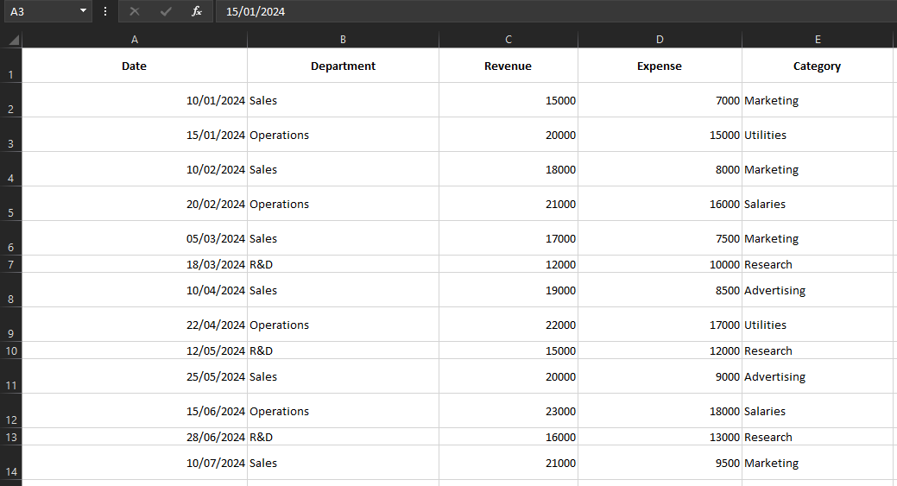

**Step 2: Next Steps in Power BI**

**Import Data:**

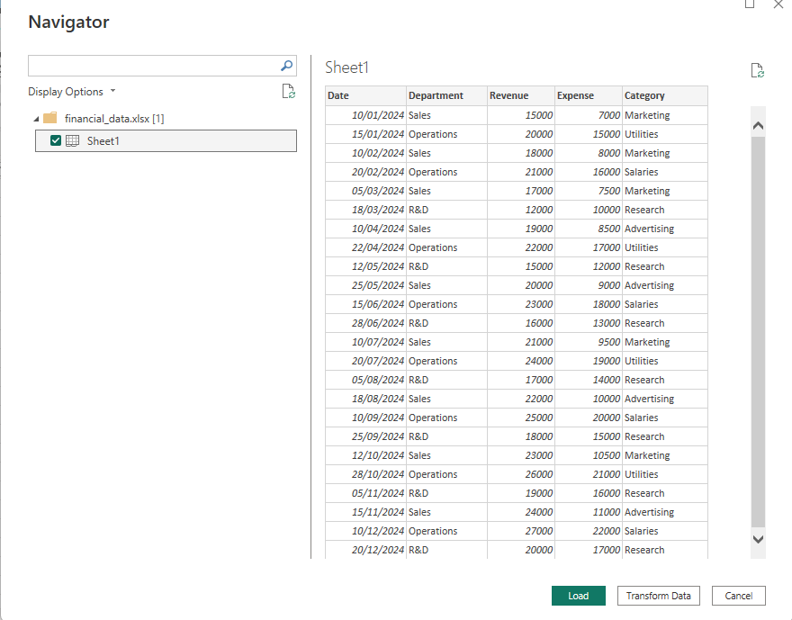

**Check Data:**

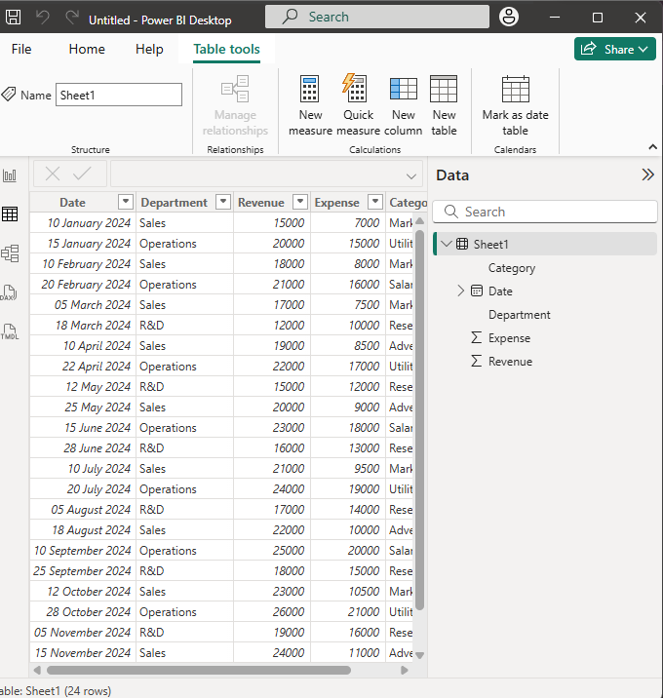

**Create New Columns/Measures:**

**Create a new column Profit:**

Profit = [Revenue] - [Expense]

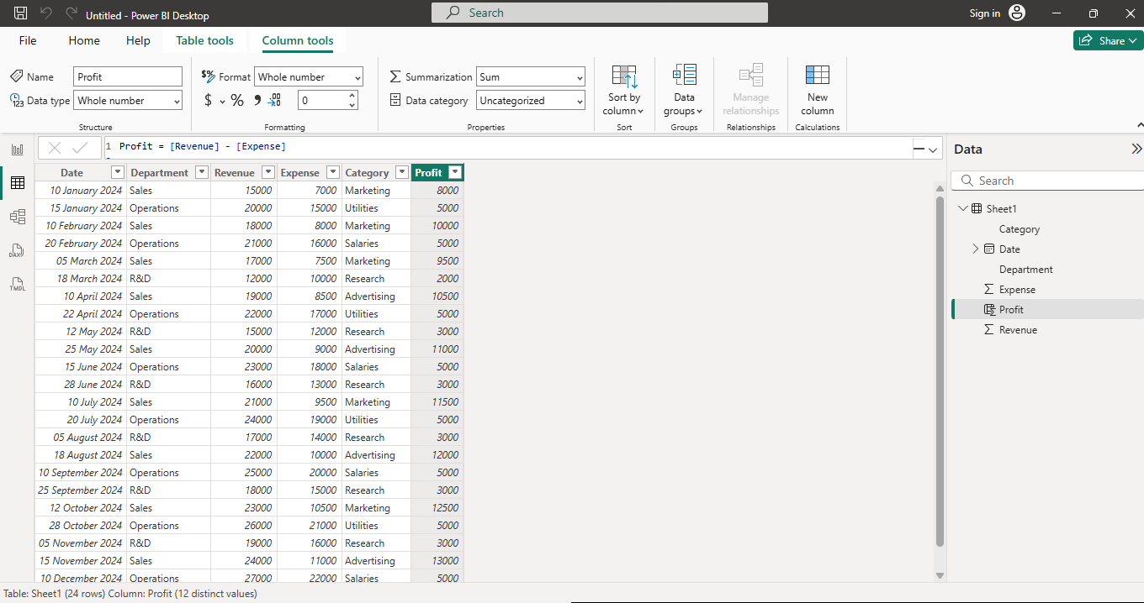

**Create Key Metrics (Measures)**

**Total Revenue**

Total Revenue = SUM(Sheet1[Revenue])

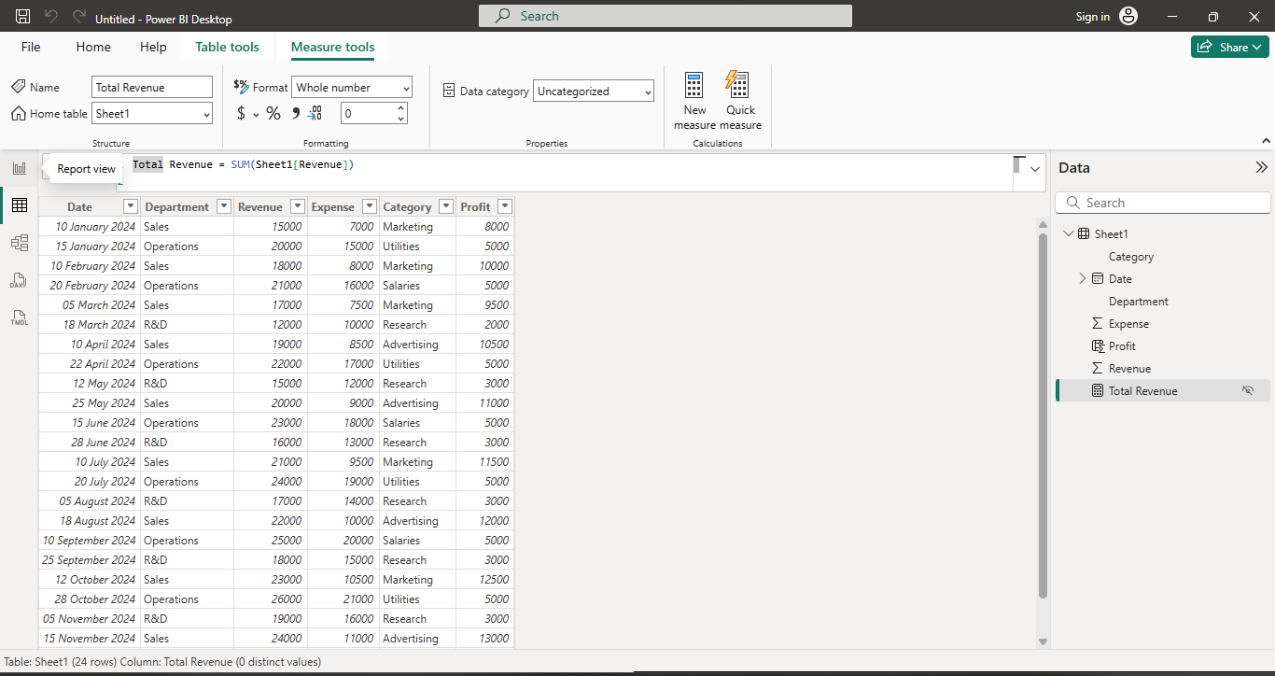

**Total Expense**

Total Expense = SUM(Sheet1[Expense])

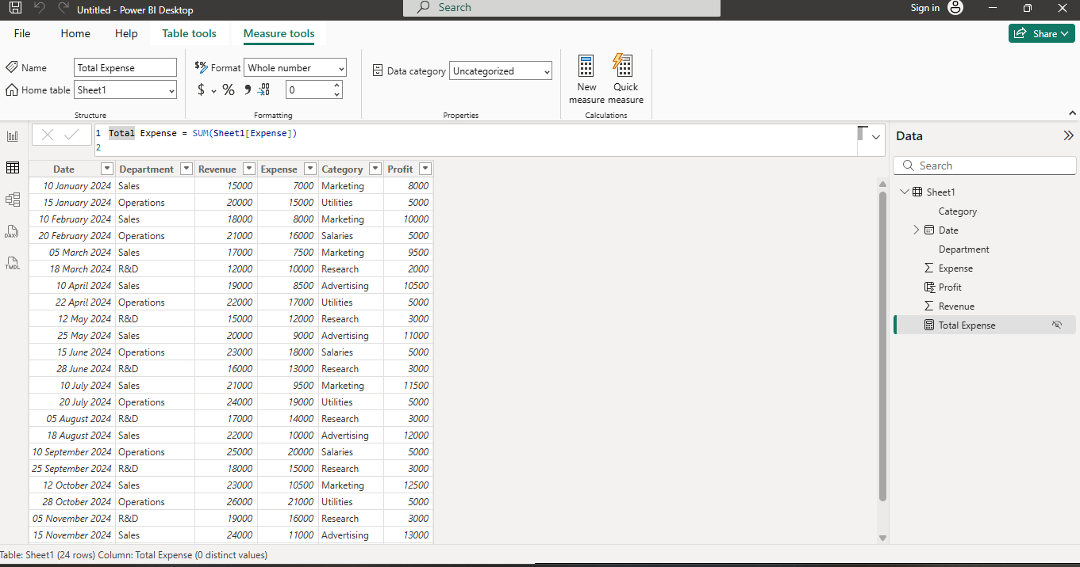

**Total Profit**

Total Profit = SUM(Sheet1[Profit])

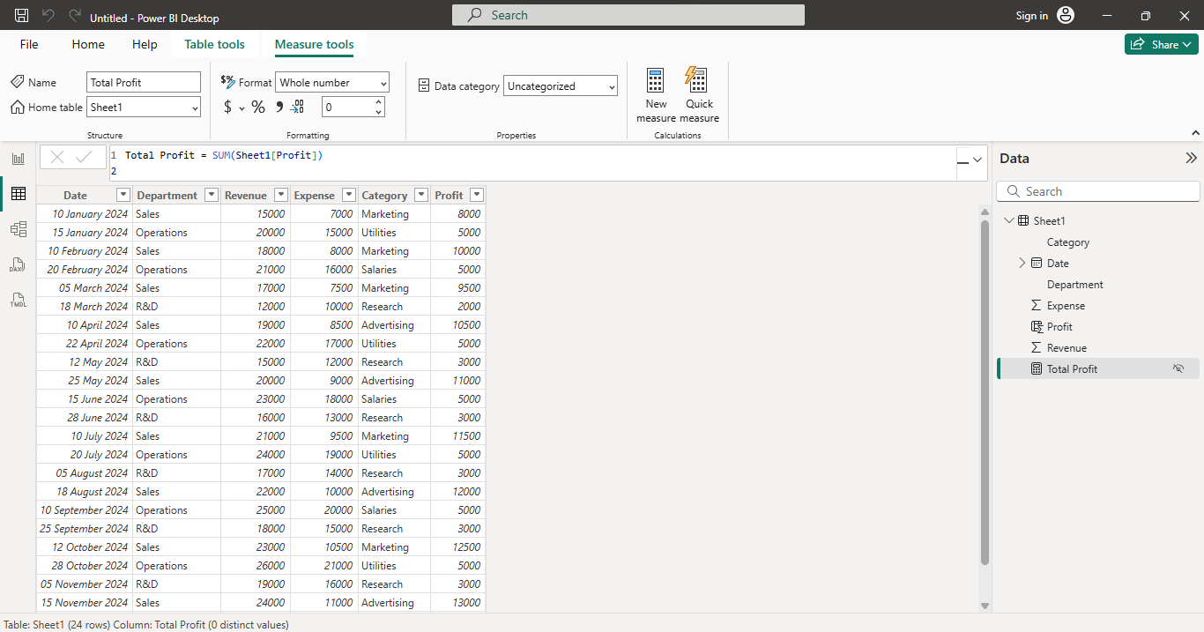

**Profit Margin**

Profit Margin = DIVIDE([Total Profit], [Total Revenue], 0)

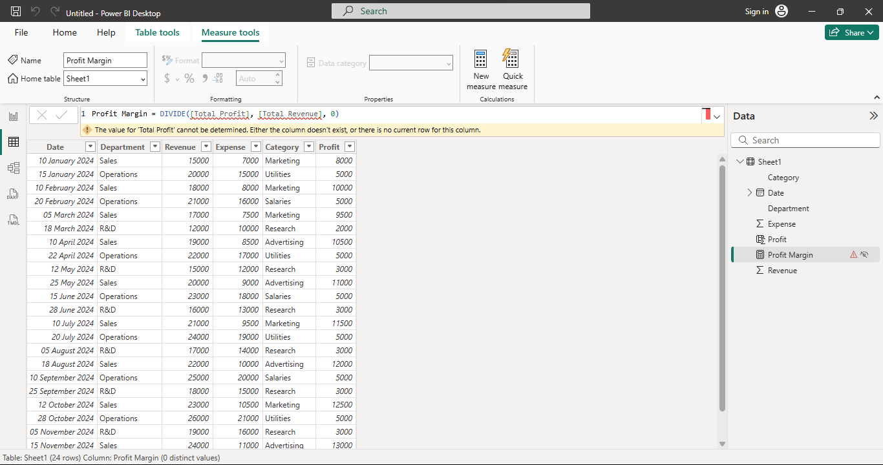

**Cumulative Revenue**

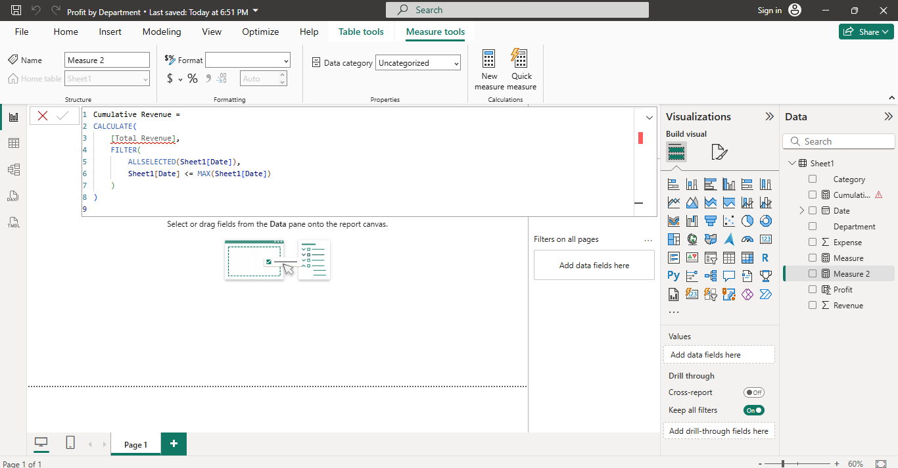

**Create Visuals**

**Top Revenue by Department**

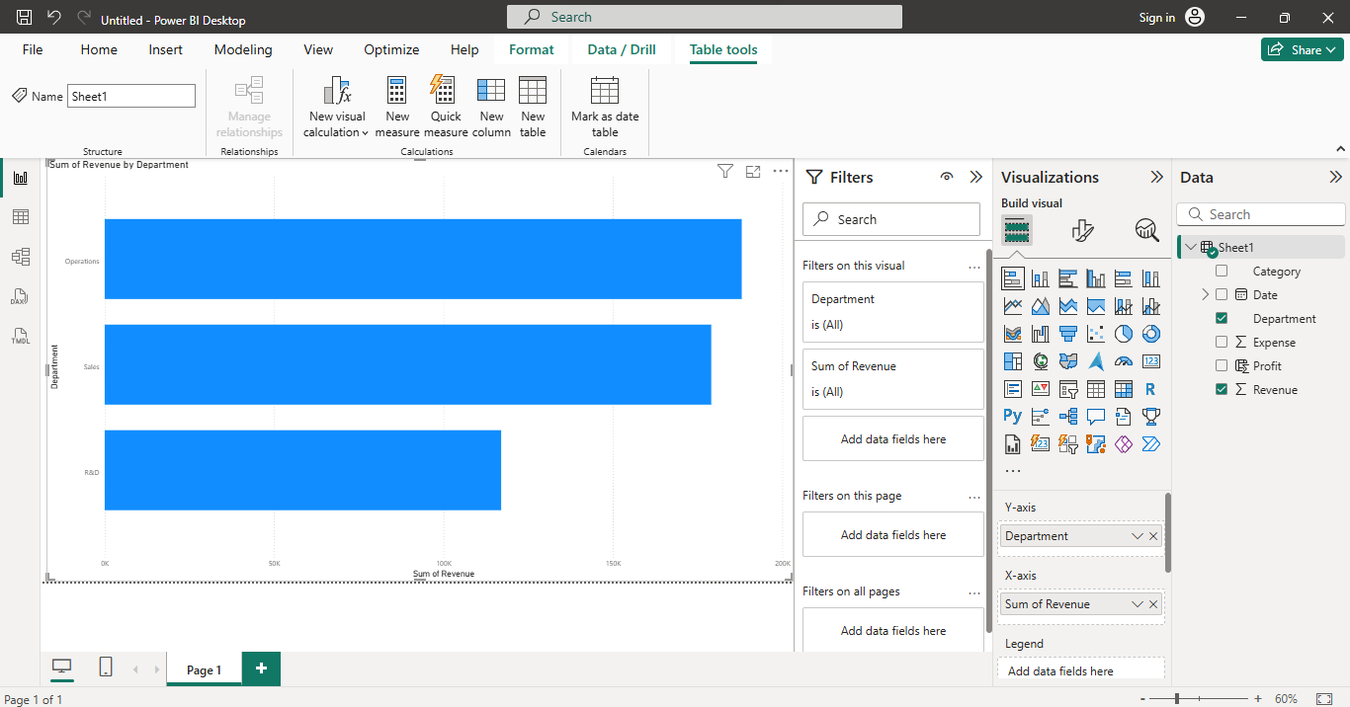

**Monthly Revenue Trend**

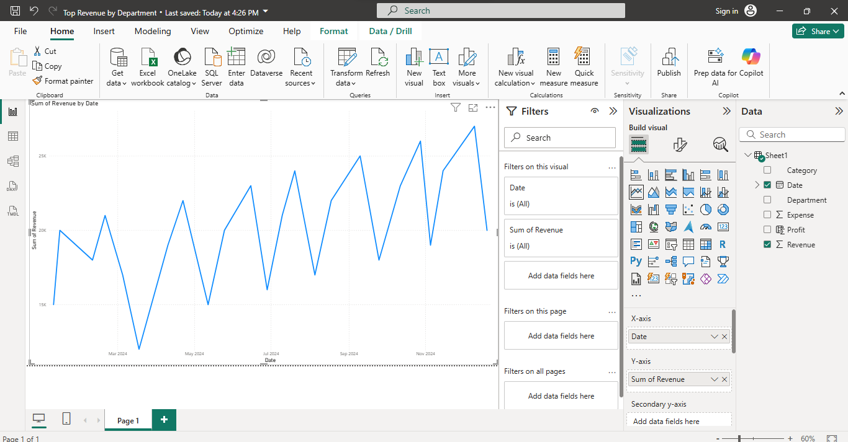

**Profit by Category**

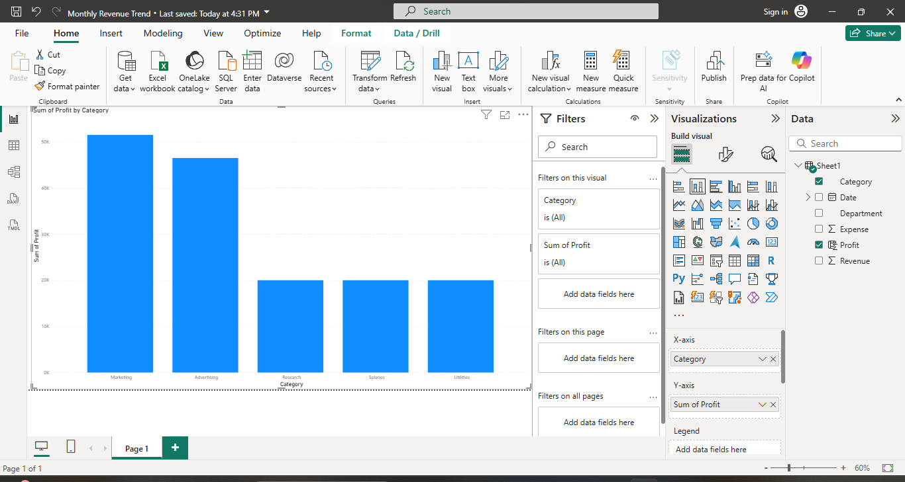

**Revenue vs. Expense**

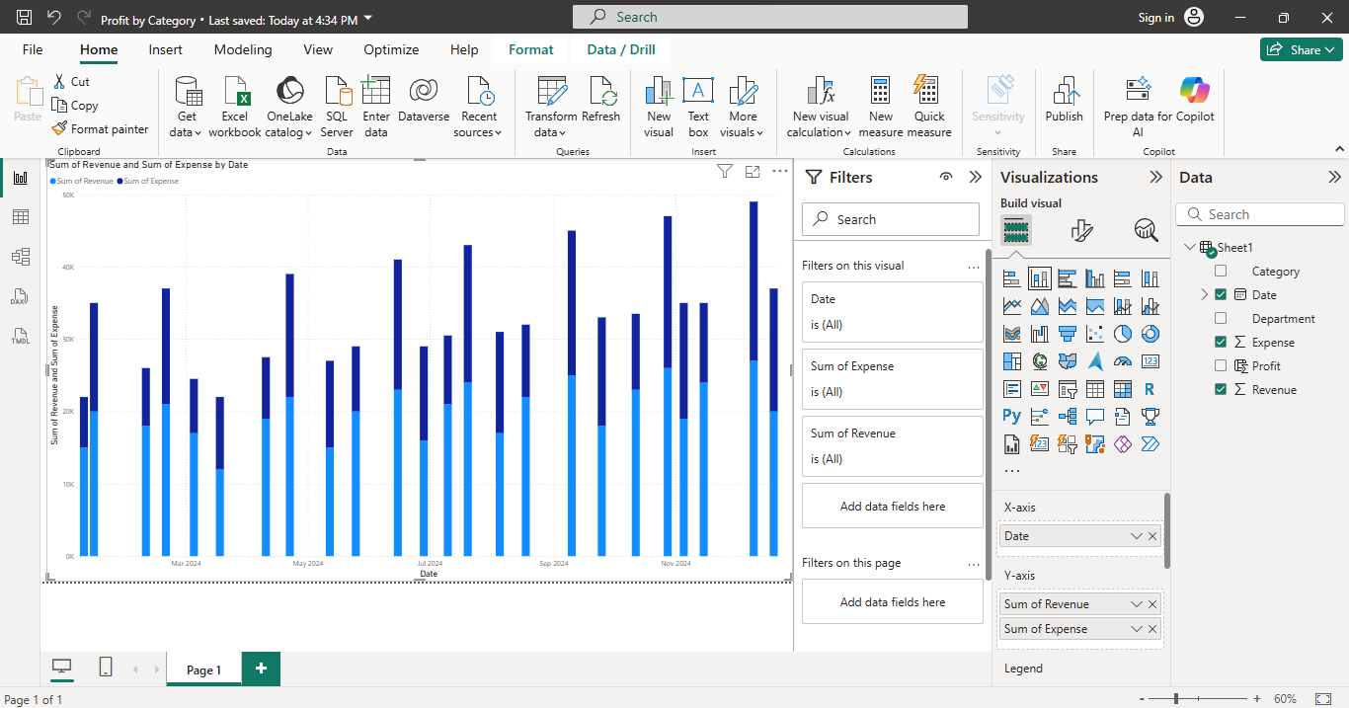

**Revenue vs Expense Bar Chart per Department**.

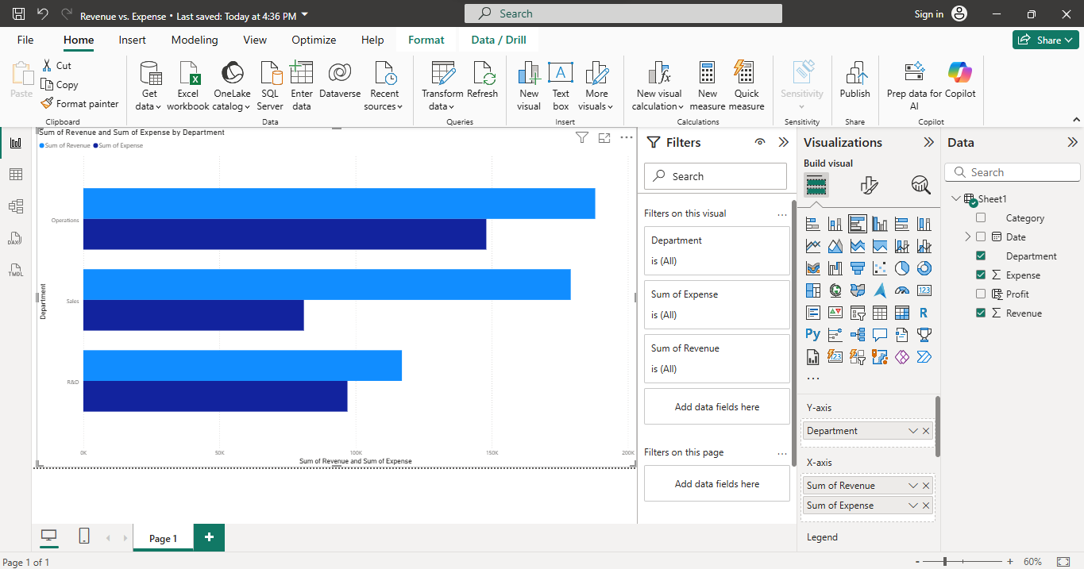

**Steps to Add KPI Cards in Power BI**

Add a Card visual

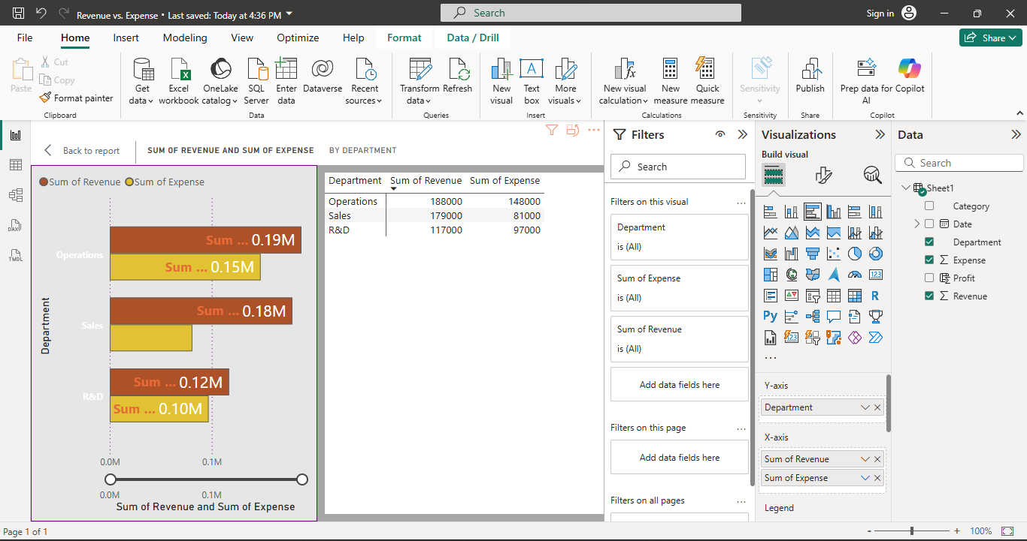

**Revenue vs Expense Analysis – 2024 Sections & Visuals**

Row 1 — Bar Chart: Department Analysis

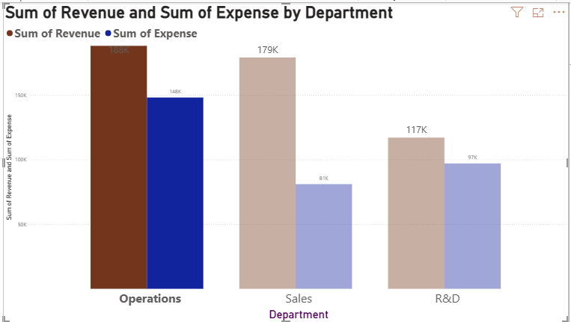

Row 2 — Pie Chart: Category Analysis

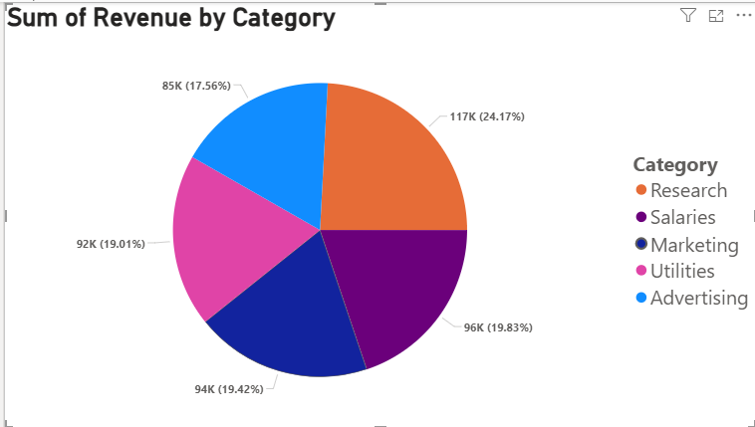

Row 3 — Monthly Trend

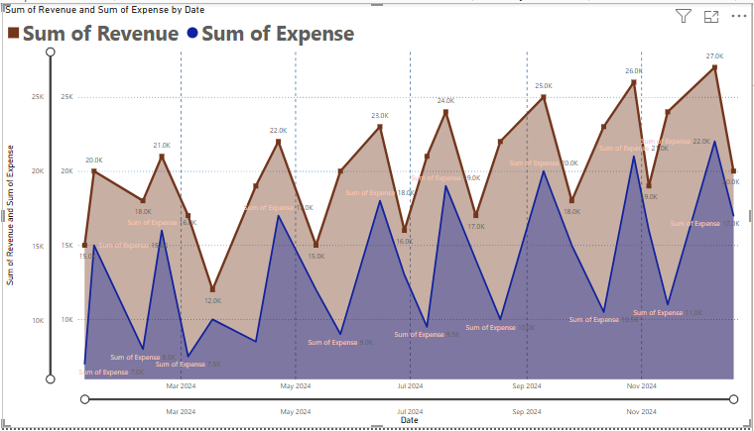

Row 4 — Profit by Department

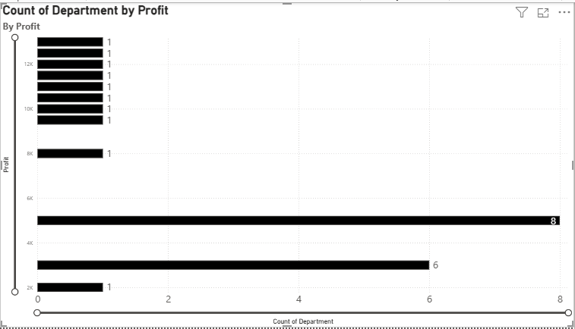

DAX Measures

**Total Revenue**

Total Revenue = SUM(Sheet1[Revenue])

**Total Expense**

Total Expense = SUM(Sheet1[Expense])

**Total Profit**

Total Profit = [Total Revenue] - [Total Expense]

**Profit Margin (%)**

Profit Margin (%) =

DIVIDE([Total Profit], [Total Revenue], 0)

**Cumulative Revenue (optional – to show running total over time)**

Cumulative Revenue =

CALCULATE(

[Total Revenue],

FILTER(

ALLSELECTED(Sheet1[Date]),

Sheet1[Date] <= MAX(Sheet1[Date])

**Revenue per Department**

Revenue per Department = [Total Revenue]

Key Metrics:

| Metric | Value |
| --- | --- |
| Total Revenue | 484,000 |
| Total Expense | 326,000 |
| Total Profit | 158,000 |
| Profit Margin | 32.64% |

**Department-wise Performance:**

| Department | Revenue | Expense | Profit |
| --- | --- | --- | --- |
| Operations | 188,000 | 148,000 | 40,000 |
| Sales | 179,000 | 81,000 | 98,000 |
| R&D | 117,000 | 97,000 | 20,000 |

* Most Profitable Department: *Sales*
* Highest Revenue: *Operations*
* Highest Expense: *Operations*
* Best Profit Margin: *Sales*

**Category-wise Analysis:**

| Category | Revenue | Profit |
| --- | --- | --- |
| Research | 117,000 | 20,000 |
| Salaries | 96,000 | 20,000 |
| Marketing | 94,000 | 51,500 |
| Utilities | 92,000 | 20,000 |
| Advertising | 85,000 | 46,500 |

* Top Revenue Category: *Research*
* Top Profit Contributor: *Marketing*
* *Advertising* also shows strong profitability.

**Monthly Analysis:**

| **Month** | **Revenue** | **Expense** |
| --- | --- | --- |
| Jan | 35,000 | 22,000 |
| Feb | 39,000 | 24,000 |
| Mar | 29,000 | 17,500 |
| Apr | 41,000 | 25,500 |
| May | 35,000 | 21,000 |
| Jun | 39,000 | 31,000 |
| Jul | 45,000 | 28,500 |
| Aug | 39,000 | 24,000 |
| Sep | 43,000 | 35,000 |
| Oct | 49,000 | 31,500 |
| Nov | 43,000 | 27,000 |
| Dec | 47,000 | 39,000 |

* *Highest Revenue Month*: December — 47,000
* *Lowest Expense Month*: March — 17,500
* *Highest Profit Month*: Likely July / October

**Insights:**

* Sales department leads in profit despite not having the highest revenue.
* Marketing & Advertising provide excellent ROI compared to cost-heavy Research & Operations.
* Expenses tend to peak in June & December — possibly due to seasonal factors.
* Profitability dips slightly in months where expenses rise significantly (e.g., June, December).

**Dashboard Features:**

* KPI Cards: Total Revenue, Expense, Profit, Margin
* Bar Chart: Revenue & Expenses by Department
* Pie Chart: Revenue & Profit by Category
* Line Chart: Monthly Trends of Revenue & Expense
* Clustered Chart: Profit by Month
* Filters: By Department, Category, Month

**Skills Showcased:**

* Data Cleaning & Transformation
* DAX Measures: Profit & Margin Calculations
* Data Visualization Best Practices
* Business Insight Generation
* Stakeholder-ready Presentation

**Tools & Technologies Used**

| Tool / Technology | Purpose / Usage |
| --- | --- |
| Microsoft Power BI | Building the interactive dashboard, creating visualizations, and sharing insights. |
| Microsoft Excel / CSV | Data cleaning, formatting, and initial exploration of raw data before importing to Power BI. |
| DAX (Data Analysis Expressions) | Writing measures and calculated columns for KPIs like Profit, Profit Margin, etc. |
| Power Query (M language) | Data transformation & shaping while loading into Power BI. |
| Data Visualization Techniques | Best practices for creating intuitive and meaningful charts & KPIs. |